Below is the home screen. There we can able to see the list of mortgages. I have used the sorting to mortgage type with interest rate.

We are listing all the data that we are getting from MortgageData.dll.

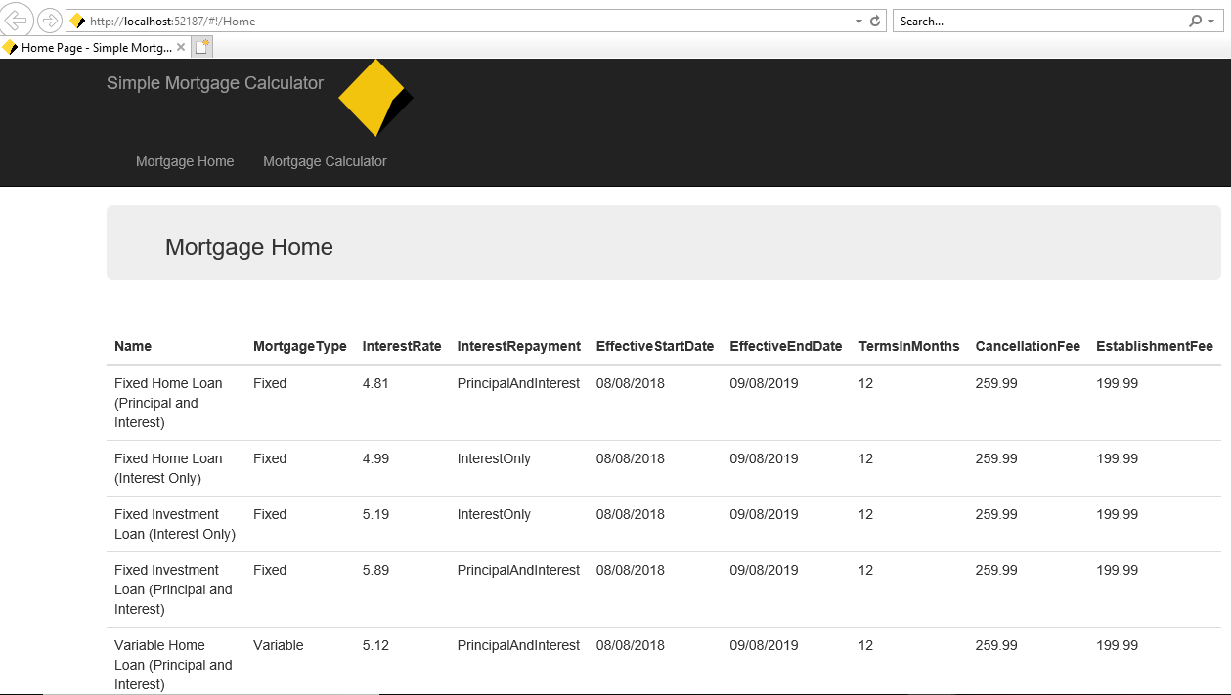

Below screen shows the mortgage calculation.

Here we have to enter the Principal amount, Loan terms in years and mortgage type that we have to choose from the dropdown.

If we click calculate button, then it will display the Total Repayment and total interest for that period.

